GITEA Installation through Ansible and Docker

Table of Contents

Installation of Gitea with Docker: 1

What is Gitea? 1

Prerequisites: 1

Installation of Gitea with Docker: 2

Creation of Volumes for the Gitea and Database: 7

Configuration of initial setup of Gitea: 7

Ansible File attachment: 8

### Installation of Gitea with Docker:

### What is Gitea?

Gitea is an open-source forge software package for hosting software development version control using Git as well as other collaborative features like bug tracking, wikis and code review.

**Prerequisites:**

Before we install Gitea through Ansible and Docker. We need to install the Ansible and Docker in the machines.

SSH needs to be done between the machines with Docker installed.

### Installation of Gitea with Docker:

**Create a Docker network:**

Creating docker network to make the containers under the same network.

Below commands will help us to create the docker network.

$ sudo docker network create gitea

$sudo docker network ls

**Creating docker containers with the respective images:**

**Postgres:** PostgreSQL, also known as Postgres, is a free and open-source relational database management system emphasizing extensibility and SQL compliance.

**docker run --name psql --network gitea -p 3306:3306 -e POSTGRES_USER=gitea -e POSTGRES_PASSWORD=myworld -e POSTGRES_DB=gitea -d postgres:9.6**



**Gitea:**

**docker run -dit --name gitea --network gitea -p 3000:3000 -e DB_TYPE=postgres gitea/gitea:latest**



**To see all the containers installed:**

**docker ps**



**Then open the browser with the host IP and the port:**

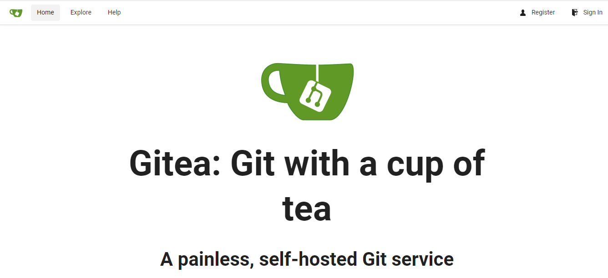

**Click on Register:**

**It will redirect to initial configuration. Fill with the appropriate details**

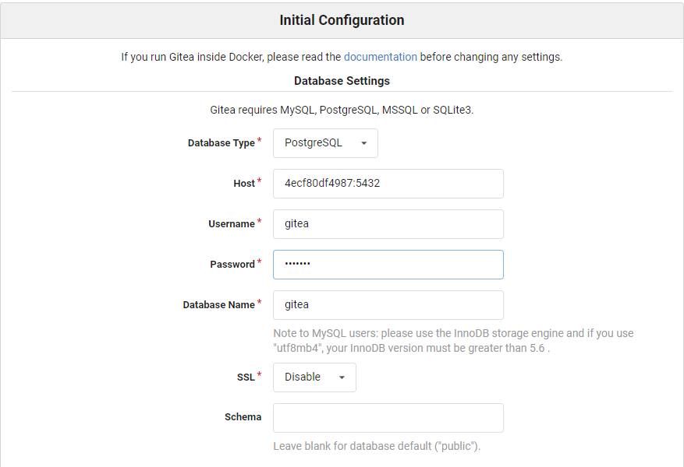

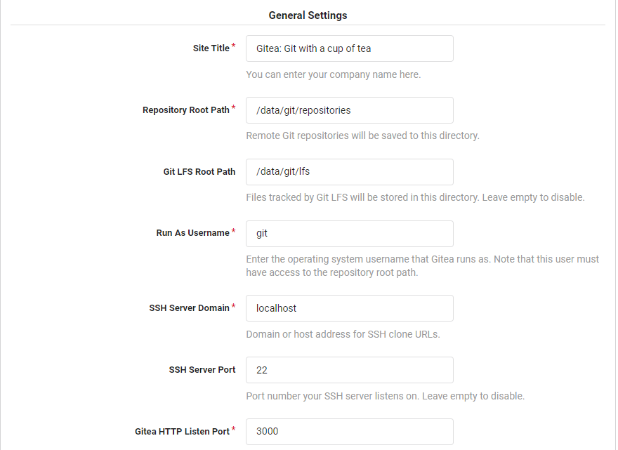

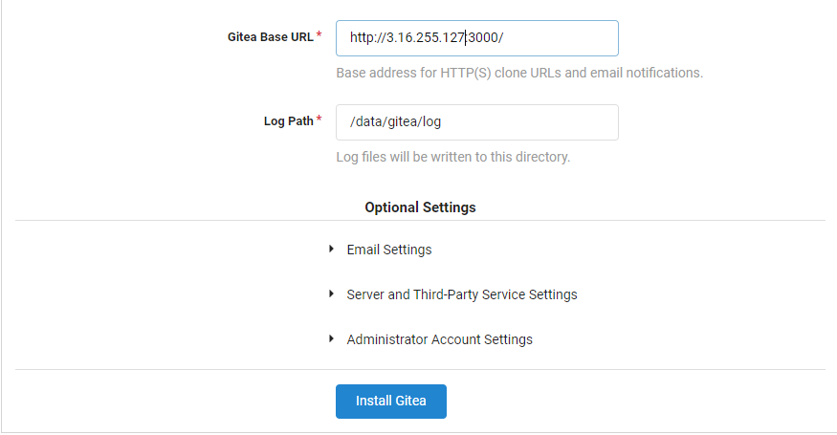

**Click on install gitea it will redirect to registration page to register fill in the details to get the UI of the gitea dashboard page**

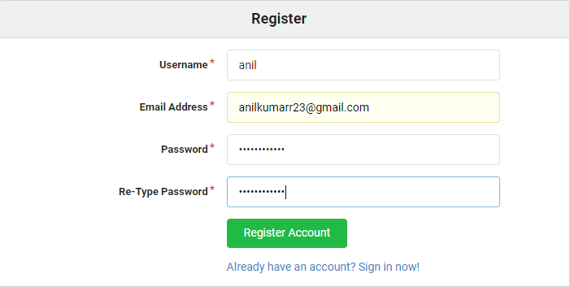

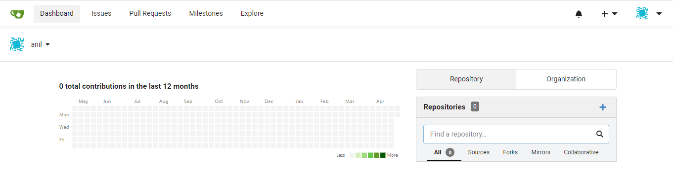

**Create your first repository and enjoy and explore from here.**

Installation of Gitea through Ansible:

Installation through ansible will save our time and effort and also it’s a easy way of installation.

### Creation of Volumes for the Gitea and Database[:](https://docs.docker.com/engine/install/ubuntu/#install-using-the-repository)

Docker volume is a method for persisting data and configuration in Docker containers. When you remove any container, the data and configurations are still available in the Docker volume. So you will need to create a data and log volumes to backup which we can store in our local machine.

We have create volumes for Gitea and Database as given below through ansible.

     - /etc/postgres:/var/lib/postgresql/data

- /home/ansibleadm/gitea:/data

### Configuration of initial setup of Gitea:

Initial configuration of Gitea is done through templates which is saved with the file name gitea.ini.j2. In the template file we will enter the all the configuration details manually and restart the container that would setup the configuration and move up to the sign up page.

We get the data for the configuration for the container directory /data we can mount that data information to our local volumes.

**Restart of the container**:

Once we finish initial configuration is done container is restarted to make the changes get effected.

## Ansible File attachment:

Once SSH is done for the machines then we can execute the below attached file to install gitea through ansible

. 